FORMAT FOR PREPARATION OF PROJECT REPORT
FOR
Foundations of Artificial Intelligence

AI RESUME SCREENER

A PROJECT REPORT

Submitted by
2116240701357 – NETHRA CHANDRAGANDHI T
2116240701358 – NETHRA G


October, 2026

BONAFIDE CERTIFICATE

Certified that this project report “AI RESUME SCREENER” is the bonafide work of “NETHRA CHANDRAGANDHI T and NETHRA G” who carried out the project work under my supervision.

SIGNATURE OF THE FACULTY INCHARGE

Submitted for the Practical Examination held on _________________

SIGNATURE OF THE INTERNAL EXAMINER

TABLE OF CONTENTS
CHAPTER NO. TITLE PAGE NO.
ABSTRACT 4
- INTRODUCTION 5
  - OBJECTIVE OF THE PROJECT
  - SCOPE OF THE PROJECT
  - EXISTING & PROPOSED SYSTEM

- LITERATURE REVIEW 10
3 PROPOSED SYSTEM 12
3.1 ARCHITECTURE DIAGRAM
4 MODULES DESCRIPTION 15
4.1 RESUME PROCESSING MODULE
4.2 REQUIREMENT ANALYSIS MODULE
4.3 RESUME MATCHING MODULE
4.4 SEARCH ALGORITHMS MODULE
4.5 CANDIDATE RANKING MODULE
4.6 RESULTS GENERATION MODULE
5 IMPLEMENTATION AND RESULTS 20
5.1 EXPERIMENTAL SETUP
5.2 RESULTS
6 CONCLUSION AND FUTURE WORK 26
7 REFERENCES 28
ABSTRACT
The recruitment process involves analysing numerous resumes to identify candidates whose skills, qualifications, and experience match the requirements of a job position. Manual resume screening is time-consuming and may lead to inconsistent evaluations. To address these challenges, the project AI Resume Screener proposes an Artificial Intelligence-based system that assists recruiters in identifying suitable candidates efficiently.
The proposed system accepts candidate resumes and job descriptions as input. It extracts relevant information, including technical skills, educational qualifications, work experience, projects, and certifications. The extracted details are compared with the job requirements to evaluate the relevance of each candidate's profile. Artificial Intelligence search algorithms, including Breadth-First Search (BFS), AO* Search, and Backtracking, are considered for exploring candidate attributes, evaluating requirement combinations, and identifying suitable matches.
The system calculates relevance scores and ranks candidates according to their compatibility with the specified job requirements. The results help recruiters compare candidate profiles, identify matching skills, and review relevant qualifications in a structured manner. This approach aims to reduce repetitive manual effort and improve consistency in preliminary resume screening.
1. INTRODUCTION
Recruitment is an important process in every organisation because selecting suitable candidates contributes to productivity, performance, and organisational growth. With the increasing use of online job portals and digital recruitment platforms, organisations receive a large volume of resumes for individual job openings. Reviewing each resume manually requires considerable time and effort, particularly when recruiters must compare multiple candidates against several job requirements.
Traditional resume screening generally involves reading resumes, identifying relevant qualifications, checking technical skills, evaluating experience, and comparing candidate profiles with the job description. This process can become difficult when resumes use different formats, terminology, and presentation styles. Manual screening may also result in inconsistent assessments when different recruiters interpret the same requirements differently.
Artificial Intelligence (AI) provides techniques for analysing information, searching through possible solutions, evaluating alternatives, and supporting decision-making. In recruitment, AI-based resume screening can help extract relevant information from resumes and compare it with the requirements of a particular job position. Natural Language Processing (NLP), information extraction, similarity analysis, scoring methods, and intelligent search techniques can be used to support this process.
The project AI Resume Screener focuses on developing a structured approach to preliminary resume evaluation. The system takes resumes and job descriptions as inputs and identifies important attributes such as skills, education, experience, projects, and certifications. It then evaluates the relationship between these attributes and the job requirements to determine candidate relevance.
The project also relates to the problem-solving concepts covered in Foundations of Artificial Intelligence. Breadth-First Search can be used to explore requirement and candidate-attribute nodes level by level. Backtracking can support the exploration of alternative combinations of candidate qualifications while rejecting combinations that fail required conditions. AO* Search, which operates on AND-OR graphs, can represent the selection of combinations of requirements and alternative ways of satisfying them. These algorithms require an appropriate state-space representation and should be implemented and evaluated as part of the actual system before their effectiveness can be claimed.
The main objective of the project is to assist recruiters in identifying relevant candidates through automated information analysis and systematic comparison. The system is intended to reduce repetitive screening effort, provide consistent evaluation criteria, and organise candidate profiles according to their relevance to a job description.
The project does not aim to replace human judgement in recruitment. Instead, it provides decision-support information that recruiters can use to review candidates more efficiently. Fairness, transparency, privacy, and human supervision are important considerations because an automated system may produce inaccurate or biased results if its input data or evaluation criteria are unsuitable.
1.1 OBJECTIVE OF THE PROJECT
The primary objectives of AI Resume Screener are:
- To develop a system that accepts candidate resumes for preliminary screening.
- To extract relevant information, including skills, education, experience, projects, and certifications.
- To analyse job descriptions and identify essential and preferred requirements.
- To compare candidate profiles with job-specific requirements.
- To apply suitable AI search and problem-solving techniques to requirement evaluation.
- To assign relevance scores and rank candidate profiles based on defined criteria.
- To reduce the time and repetitive effort involved in preliminary resume screening.
- To provide understandable screening results that support human decision-making.
1.2 SCOPE OF THE PROJECT
The scope of the project is limited to preliminary resume analysis and candidate-job matching. It focuses on processing resume information, identifying relevant qualifications, evaluating requirement satisfaction, and presenting candidate rankings. The quality of the output depends on the accuracy of extracted information and the matching rules used by the system. The project does not independently verify candidate claims, determine personality, or make final hiring decisions.
1.3 EXISTING AND PROPOSED SYSTEM
The existing resume screening process is primarily based on manual evaluation, keyword searches, and predefined filtering criteria. Recruiters review candidate resumes individually to identify relevant skills, educational qualifications, work experience, and certifications. When a large number of applications are received for a single job position, this process requires considerable time and effort. Manual evaluation may also lead to inconsistent assessments because different recruiters may interpret job requirements differently.
Traditional keyword-based screening systems search for specific words or phrases in resumes. Although this approach helps identify candidates who mention the required skills, it may overlook suitable candidates who describe the same skills using different terminology. These systems may also have difficulty evaluating multiple eligibility conditions simultaneously, such as educational qualifications, CGPA, experience, and technical skills.
Another limitation of the existing approach is the difficulty of ranking candidates consistently according to the importance of different job requirements. Recruiters may need to compare several resumes repeatedly before preparing a shortlist. Therefore, there is a need for a systematic screening approach that evaluates candidate information against clearly defined criteria and supports more consistent preliminary recruitment decisions.
The proposed AI Resume Screener is a web-based application designed to simplify the preliminary screening of candidate resumes using Artificial Intelligence problem-solving techniques. The system accepts job requirements and candidate resumes as input, extracts relevant information, and evaluates each candidate against the specified eligibility conditions.
The application considers required skills, preferred skills, educational qualifications, minimum CGPA, and work experience during the screening process. Constraint Satisfaction Problem (CSP) and Constraint Propagation are used to check mandatory requirements, while Backtracking Search evaluates whether a valid solution can be obtained. Heuristic Evaluation assigns scores based on predefined criteria, and Best-First Search arranges eligible candidates according to their heuristic scores.
The system displays the extracted candidate information, eligibility status, suitability score, and search results in a structured interface. This enables recruiters to compare candidate profiles and identify applicants who meet the specified requirements. By combining constraint checking and heuristic-based search, the proposed system aims to reduce repetitive manual work and provide a consistent approach to preliminary resume screening.
The system is intended to assist recruiters rather than replace human judgement. Its effectiveness depends on the accuracy of extracted resume information and the suitability of the defined evaluation criteria. Further improvements can include support for additional resume formats, enhanced text processing, and testing with a larger number of candidate profiles.
The system also provides a systematic approach to comparing candidate profiles based on job-specific requirements. It reduces repetitive manual effort by automating eligibility checks and candidate evaluation. The use of heuristic scoring helps organise eligible candidates according to their suitability scores. Overall, the proposed system supports efficient preliminary recruitment while allowing recruiters to make the final selection decisions.

2. LITERATURE REVIEW

Artificial Intelligence has been widely studied as a means of solving complex problems through search, reasoning, knowledge representation, and decision-making. These concepts provide a foundation for systems that must evaluate alternatives and identify suitable solutions. In recruitment, similar approaches can be adapted to support the analysis and comparison of candidate profiles.
Traditional recruitment systems primarily rely on keyword searches and manually defined filters. Such approaches can quickly identify resumes containing specified words or qualifications. However, they may fail to recognise relevant candidates when equivalent skills are expressed using different terminology. They may also overlook the context in which a skill appears, such as whether it was used in a project, internship, or professional role.
Natural Language Processing provides methods for analysing textual information and extracting meaningful details from unstructured documents. NLP-based techniques can identify entities, keywords, qualifications, and relationships within resume text. Such information can be structured into fields that can be compared with a job description. The quality of the analysis depends on the extraction method, the format of the input document, and the complexity of the language used.
Information retrieval and similarity-based methods provide another foundation for resume screening. A candidate's resume can be represented through its extracted attributes and compared with a job description using predefined rules or similarity measures. A weighted scoring approach can assign different importance levels to skills, educational qualifications, experience, and other requirements. This makes it possible to generate a relevance score for each candidate. However, a high score indicates compatibility with the selected criteria rather than guaranteeing that the candidate is the best person for the job.
Search algorithms are important in Artificial Intelligence because they explore a state space to identify paths or solutions that satisfy specified conditions. Breadth-First Search explores nodes level by level and is useful for systematically examining a structured set of requirements. Backtracking explores possible combinations of decisions and reverses choices when a constraint is violated. AO* Search addresses problems represented by AND-OR graphs, where a solution may require multiple conditions to be satisfied together or a suitable choice among alternatives.
These algorithms offer different approaches to representing and evaluating candidate requirements. Their usefulness depends on how the screening problem is modelled. For example, mandatory qualifications can be represented as constraints, while alternative skills or equivalent qualifications can be represented as alternative paths. Search algorithms alone do not understand resume language; they must operate on information extracted from resumes and job descriptions.
The proposed AI Resume Screener combines structured resume information, job-requirement analysis, matching rules, scoring, and AI search concepts into a single screening workflow. Compared with manual screening, this approach aims to improve consistency and reduce repetitive work. Nevertheless, automated screening systems can inherit bias from historical data or poorly chosen rules. Therefore, transparent criteria, careful testing, data privacy, and human review remain essential.

3. PROPOSED SYSTEM
The proposed AI Resume Screener is designed to automate the preliminary evaluation of candidate resumes against a given job description. The system receives resume documents and job requirements, extracts relevant candidate information, evaluates the relationship between candidate attributes and job criteria, and generates ranked screening results.
Initially, the recruiter provides the job description and specifies the essential and preferred qualifications for the position. Candidate resumes are then uploaded to the system. The documents are processed to extract available information, including personal and contact details where necessary, educational qualifications, technical skills, work experience, projects, and certifications.
The extracted information is converted into a structured representation so that each candidate can be evaluated using the same set of criteria. The job description is also analysed to identify the requirements against which the candidates will be assessed. The matching component compares the extracted attributes with the job criteria and determines which requirements are satisfied, partially satisfied, or not identified in the resume.
The AI search component can represent the screening process as a state space consisting of candidate attributes and job requirements. BFS can explore the represented nodes systematically. Backtracking can examine possible combinations of qualifications while rejecting combinations that violate defined constraints. AO* Search can be used where the requirements are represented through an AND-OR graph and the solution depends on selecting a suitable combination of required and alternative conditions.
After requirement evaluation, the system calculates a relevance score based on the configured scoring rules. Candidates are ranked according to their scores, and the system presents the results with supporting information such as matched skills, relevant experience, missing requirements, and the overall score. This allows recruiters to examine the basis of a ranking rather than relying only on a single number.
The proposed system is intended to support rather than replace human decision-making. Recruiters should review the extracted information and screening results before deciding which candidates should progress to the next stage.
3.1 ARCHITECTURE DIAGRAM
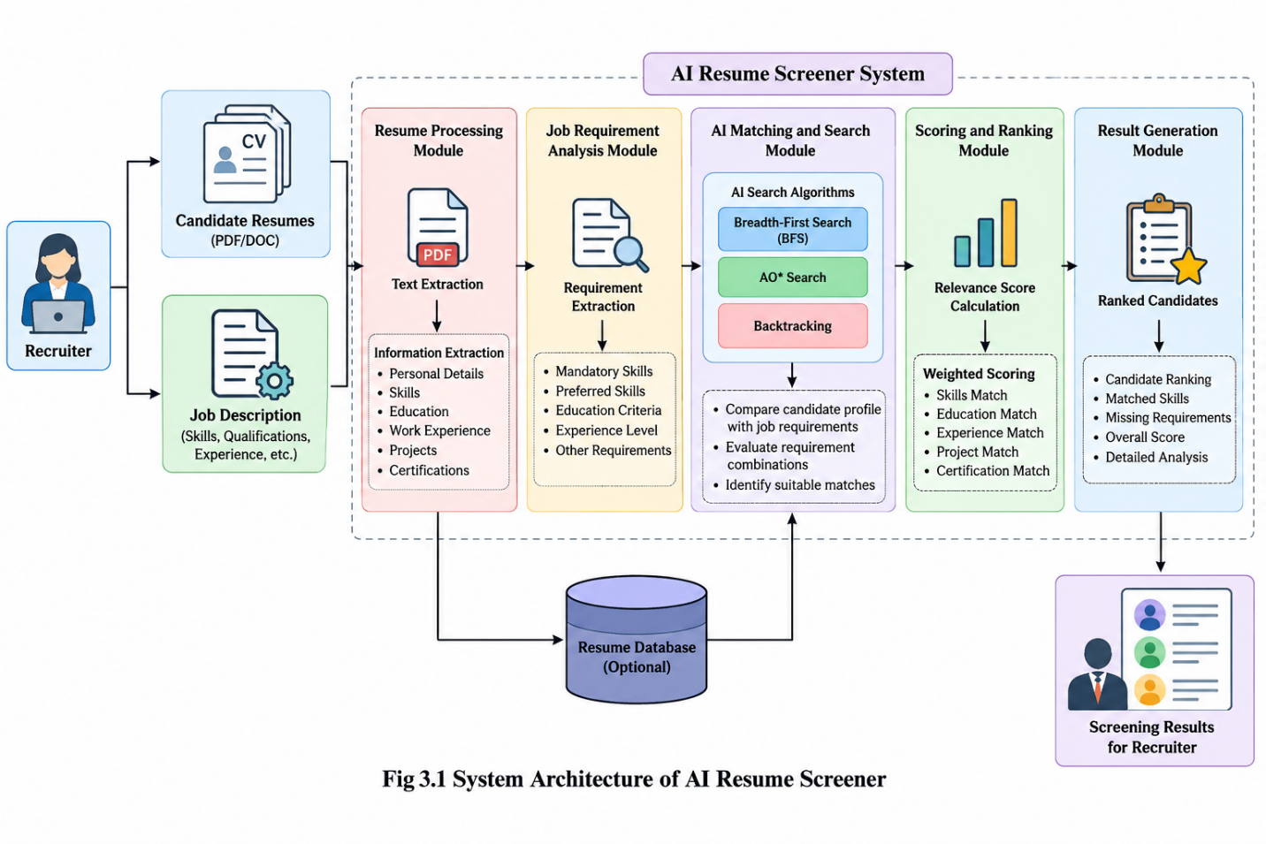

The architecture illustrates the logical workflow of the proposed system. The search algorithms shown in the diagram represent the intended AI problem-solving component; the final implementation should document which algorithms are actually coded and executed.
The architecture of AI Resume Screener consists of the following stages:
Input Layer: Accepts candidate resumes and the job description from the recruiter.
Resume Processing Layer: Extracts text and identifies candidate attributes such as skills, education, experience, projects, and certifications.
Job Requirement Analysis Layer: Converts the job description into a structured list of mandatory and preferred criteria.
AI Search and Matching Layer: Compares candidate attributes with job requirements and applies the configured search and constraint-evaluation methods.
Scoring and Ranking Layer: Calculates candidate relevance scores and arranges candidates in descending order of their scores.
Output Layer: Displays candidate rankings, matched requirements, missing criteria, and supporting screening information for recruiter review.

4. MODULES DESCRIPTION
The AI Resume Screener consists of two major modules that work together to automate the preliminary screening and evaluation of candidate resumes. The first module focuses on resume processing and job requirement analysis, while the second module performs AI-based matching, search, scoring, ranking, and result generation. These modules provide a structured workflow for analysing candidate information and identifying profiles that match the requirements of a particular job position.
4.1 RESUME PROCESSING MODULE
The resume upload and text extraction module serves as the initial stage of the system. It accepts candidate resumes in supported document formats and prepares them for further processing. Since resumes may differ in layout, structure, and formatting, the system must extract the available text and convert it into a form suitable for analysis.
After extraction, the system identifies relevant sections and attributes, including technical skills, educational qualifications, professional experience, projects, internships, and certifications. The extracted information is organised into structured fields so that candidate profiles can be compared consistently.
The module should also handle unsupported files, empty documents, and resumes from which text cannot be extracted correctly. The extracted data must be checked for accuracy because incorrect information at this stage can affect the final matching score.

4.2 REQUIREMENT ANALYSIS MODULE
The job description and requirement analysis module identifies the qualifications expected for a particular role. The recruiter provides the job description, which may contain technical skills, educational requirements, experience levels, certifications, and preferred competencies.
The system analyses the job description and converts the relevant information into a structured list of criteria. Requirements can be classified as mandatory or preferred. Mandatory requirements represent conditions that the recruiter considers essential, while preferred requirements provide additional evidence of suitability.
This structured representation serves as the reference for candidate evaluation. It also supports systematic searching because each requirement can be represented as a node, condition, or attribute in the screening process. Clear and job-related criteria help improve the consistency and interpretability of the results.
4.3 RESUME MATCHING MODULE
The AI-based resume matching module compares the structured candidate profile with the requirements extracted from the job description. It examines the extent to which the candidate's skills, qualifications, projects, certifications, and experience correspond to the specified criteria.
The matching process may use exact keyword matching, normalised text comparison, predefined equivalence rules, or similarity-based techniques, depending on the implementation. For example, a job requiring Python programming may be matched with a resume that explicitly lists Python as a technical skill. More advanced approaches could recognise related terms or equivalent descriptions, but such capabilities depend on the techniques actually implemented.
Each criterion is evaluated and classified according to its match status. This allows the system to identify relevant strengths as well as requirements that are not evident in a resume. The output of this module is used by the scoring and ranking component.
4.4 SEARCH ALGORITHMS MODULE
The search algorithms module applies Artificial Intelligence search concepts to the structured screening problem. The purpose is to explore candidate attributes and job requirements systematically rather than relying solely on an unstructured manual comparison.
Breadth-First Search (BFS): BFS explores nodes level by level, beginning from a starting node. In the proposed system, a state-space representation can organise job requirements and candidate attributes into levels. BFS can systematically visit the represented requirements and examine the associated candidate information. It is particularly useful when the search structure needs to be explored in a defined order. Its practical value depends on the state-space design and the size of the search space.
Backtracking: Backtracking explores possible combinations of decisions and reverses a choice when it fails to satisfy a constraint. In resume screening, the concept can be used to examine combinations of candidate qualifications against a set of defined requirements. When a combination violates a mandatory condition, the search can return to an earlier state and explore another possibility. Backtracking is most useful when the screening problem is formulated as a constraint-satisfaction task.
AO Search:* AO* Search is a heuristic search algorithm used for problems represented as AND-OR graphs. An AND node requires the relevant subproblems to be solved together, while an OR node allows a choice between alternative subproblems. In the screening system, mandatory job requirements can be represented through AND relationships, and acceptable alternative skills or qualification paths can be represented through OR relationships. AO* can then explore the graph to identify a suitable solution according to the defined costs and heuristic estimates.
These algorithms have different roles and are not interchangeable. BFS provides systematic traversal, Backtracking explores and rejects invalid combinations, and AO* searches an AND-OR problem representation. Their use in the final application requires explicit state definitions, transition rules, constraints, and, for AO*, appropriate cost and heuristic definitions. The algorithmic implementation should be evaluated separately from the text extraction and scoring methods.
4.5 CANDIDATE RANKING MODULE
The candidate scoring and ranking module converts the matching results into a structured relevance score. Each candidate is evaluated against the job requirements, and the importance of each criterion is determined using the scoring rules configured for the project.
For example, a scoring model may assign different weights to technical skills, educational qualifications, relevant experience, projects, and certifications. The score is calculated from the degree to which the candidate satisfies each criterion. Candidates are then ranked according to their calculated scores.
A general weighted scoring formula is:
Candidate Score = Σ (Criterion Weight × Criterion Match Value)
In this formula, the criterion weight represents the importance assigned to a requirement, while the criterion match value represents the degree to which the candidate satisfies that requirement. If the weights sum to 1 and the match values range from 0 to 1, the final score can also be represented on a 0–1 scale or multiplied by 100 to obtain a percentage-style score.
The scoring method must use clearly defined weights and match values. A numerical score should not be interpreted as a probability of hiring success unless it has been specifically designed and validated for that purpose. The ranking should be treated as a screening aid, with recruiters retaining responsibility for reviewing candidate suitability.
4.6 RESULTS GENERATION MODULE
The results and report generation module presents the outcome of the screening process in an organised format. It displays candidate information, relevance scores, ranking positions, and the requirements matched by each resume. Where supported by the implementation, it may also highlight missing or unverified requirements.
This module helps recruiters compare multiple candidate profiles without having to repeat the entire manual screening process. By presenting the reasons behind a match, the system can make the screening process easier to review and correct.
The module should avoid presenting the ranking as a final hiring decision. Recruiters must be able to review the original resumes, verify extracted information, and account for relevant experience or qualifications that the system may not recognise.

5. IMPLEMENTATION AND RESULTS

The implementation of AI Resume Screener follows a sequence of input collection, information extraction, requirement analysis, candidate matching, AI search, scoring, ranking, and result presentation. Each stage contributes to converting unstructured resume documents into structured information that can be evaluated against a specific job description.The input stage collects the candidate resumes and the job description. The resume-processing stage extracts relevant textual information and organises it into candidate attributes. The requirement-analysis stage converts the job description into a structured set of criteria. These two representations are then passed to the matching component, where the candidate's attributes are compared with the job requirements.
The search component operates on the representation of the screening problem. BFS can be used to traverse requirement nodes, Backtracking can explore valid combinations of attributes, and AO* can evaluate a suitably modelled AND-OR graph. The output of this stage contributes to requirement evaluation and candidate scoring.The ranking component calculates scores using the selected evaluation rules and sorts the candidate profiles accordingly. The final output provides a structured view of the screening results for human review.
.5.1 EXPERIMENTAL SETUP
The implementation of AI Resume Screener involves developing a system that analyses candidate resumes and evaluates their suitability for a given job description. The system follows a structured process consisting of resume input, text extraction, job requirement analysis, candidate matching, AI-based search, scoring, and result generation.
The application accepts candidate resumes and job descriptions as input. The resume processing component extracts relevant information such as technical skills, educational qualifications, work experience, projects, and certifications. The job description is analysed to identify the essential and preferred requirements for the specified position. These details are then converted into structured information for comparison.
The matching component compares the candidate's qualifications with the job requirements. Artificial Intelligence search techniques, including Breadth-First Search (BFS), AO* Search, and Backtracking, can be applied to explore the structured requirements and evaluate possible matches, provided that the corresponding algorithms are implemented in the application. The candidate scoring component calculates relevance scores using predefined matching criteria and arranges the candidates according to their scores.
The experimental setup includes sample resumes, job descriptions, defined matching criteria, and the software environment used to execute the application. Testing is performed to verify resume processing, requirement matching, score calculation, candidate ranking, and result presentation. Different resume profiles should be tested to examine how the system handles matching skills, missing information, and varying qualifications.
The system's performance should be evaluated using actual test results. Any measurements relating to processing time, extraction accuracy, or ranking quality should be recorded during testing rather than assumed.

5.2 RESULTS
The AI Resume Screener was executed using a sample candidate resume and predefined job requirements. The application extracted the candidate's details and evaluated them against the specified eligibility criteria. The results showed that one candidate was eligible out of one candidate processed.
The constraint evaluation module displayed a PASS status for education, CGPA, experience, and required skills. The Backtracking Search module confirmed that all defined constraints were satisfied and that a valid solution was found.
The Heuristic Evaluation module assigned points to the different screening criteria. The candidate obtained a heuristic suitability score of 90 out of 100. The Best-First Search module identified the candidate as being within the eligible search space and assigned the candidate the first position in the search order.
The application displayed the candidate's extracted information, eligibility status, suitability score, constraint evaluation, and search results. These outputs demonstrate how the system combines candidate information extraction with constraint checking and heuristic-based ranking to support preliminary resume screening.
The results indicate that the application successfully processed the selected test case according to its configured requirements. Further testing with multiple resumes and different job descriptions would be necessary to evaluate its performance across a wider range of recruitment scenarios. The final selection of candidates remains the responsibility of the recruiter.

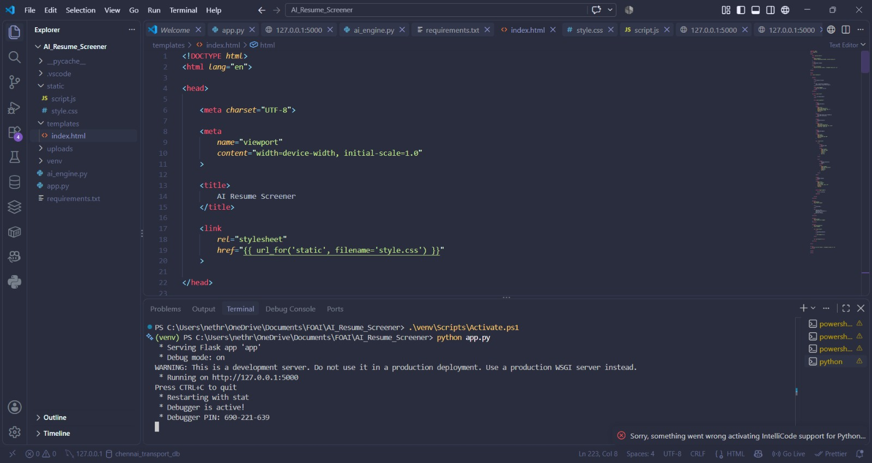Figure 5.2.1: Implementation of AI Resume Screener Using Python and Flask in VSC

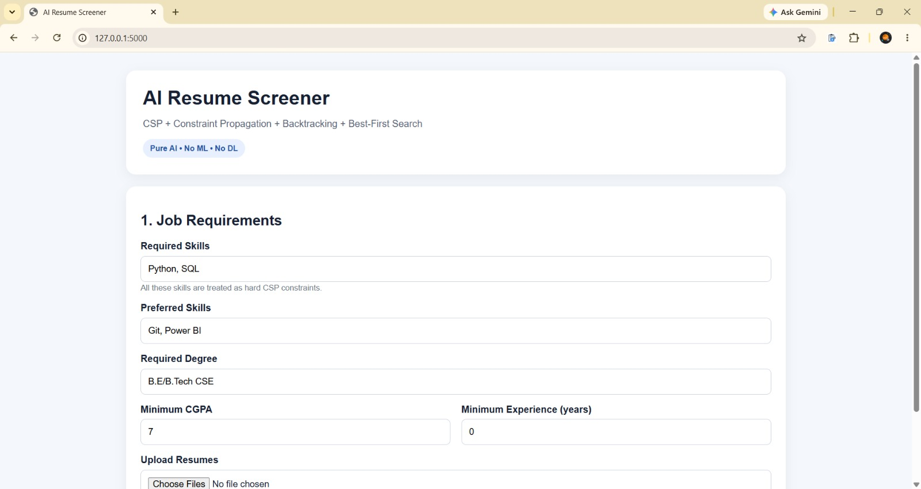
Figure 5.2.2: Job Requirements and Resume Upload Interface

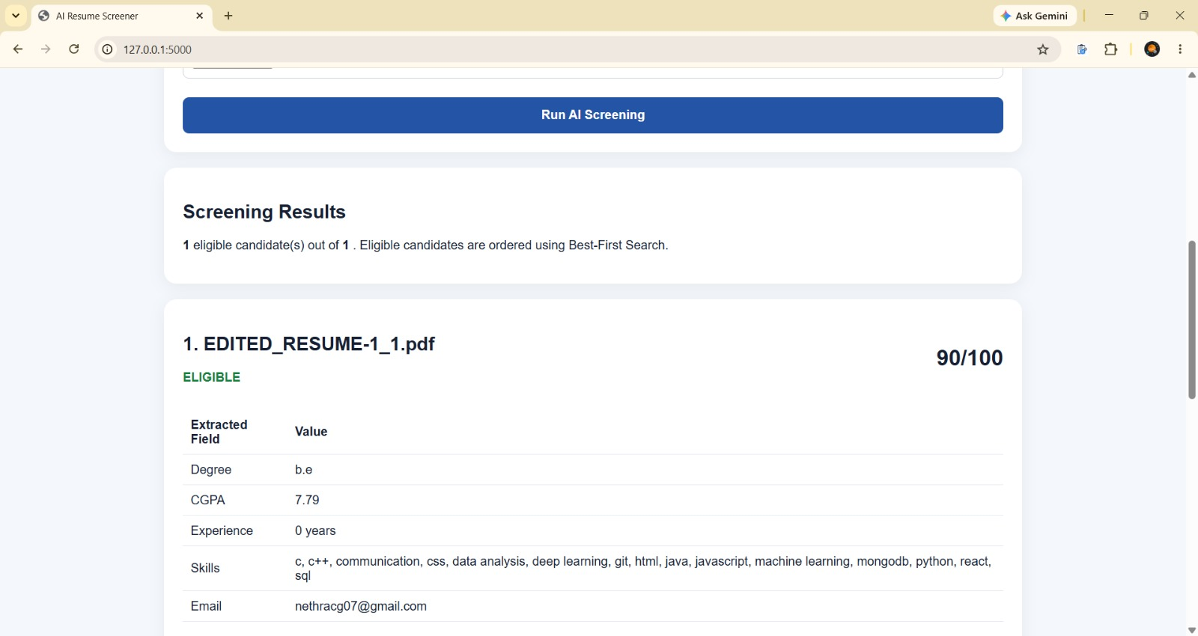
Figure 5.2.3: Candidate Screening Results

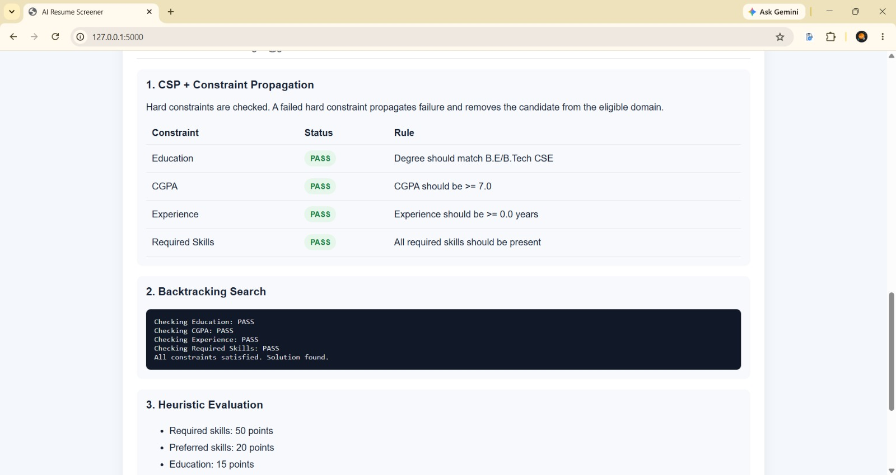
Figure 5.2.4: CSP and Constraint Propagation Results

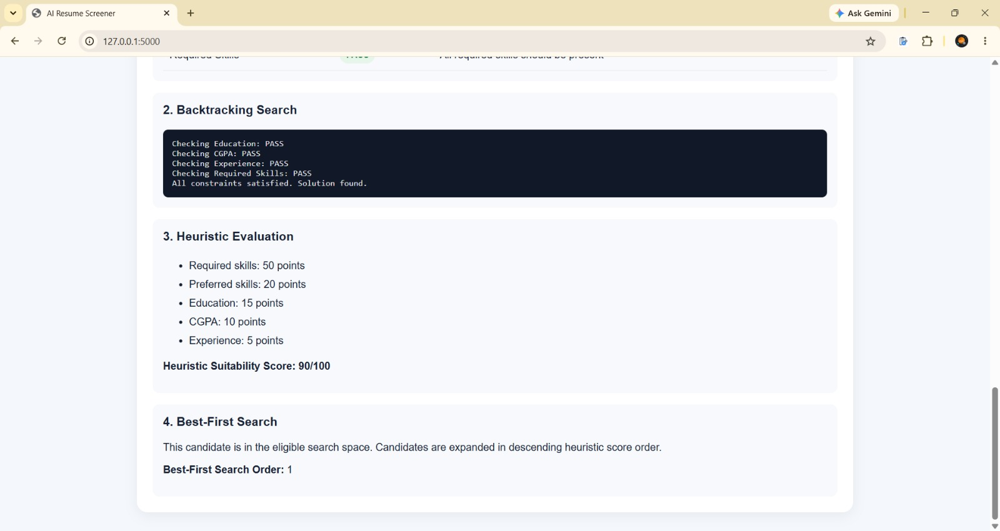
Figure 5.2.5: Backtracking Search Results

Overall Analysis of Results
The experimental results demonstrate the working of the AI Resume Screener for the selected test case. The system successfully evaluated the candidate's educational qualifications, CGPA, experience, and required skills against the specified job criteria. The heuristic evaluation produced a suitability score of 90/100, and Best-First Search placed the eligible candidate at the first position. The results illustrate how constraint checking and heuristic-based search can support preliminary resume screening. Further testing with multiple candidate resumes and different job requirements can help evaluate the consistency and effectiveness of the system.

6. CONCLUSION AND FUTURE WORK

The project AI Resume Screener presents an Artificial Intelligence-based approach to automating the preliminary screening of candidate resumes. The system evaluates candidate profiles against predefined job requirements, including technical skills, educational qualifications, CGPA, and work experience. By extracting relevant information from resumes and comparing it with the specified criteria, the application helps recruiters identify candidates who satisfy the required conditions.
The system incorporates Artificial Intelligence problem-solving techniques such as Constraint Satisfaction Problem (CSP), Constraint Propagation, Backtracking Search, Heuristic Evaluation, and Best-First Search. CSP and Constraint Propagation are used to verify mandatory eligibility conditions, while Backtracking Search determines whether a valid solution can be found. Heuristic Evaluation assigns scores based on the importance of different screening criteria, and Best-First Search arranges eligible candidates according to their heuristic scores.
During testing, the application processed a sample candidate resume and displayed the extracted candidate information, constraint validation results, and suitability score. The tested candidate received a score of 90/100, satisfied the configured constraints, and was assigned the first position in the search order. These results demonstrate the working of the screening process for the selected test case. The application provides a structured method for comparing candidate profiles and can reduce repetitive manual effort during preliminary recruitment. However, the effectiveness of the system depends on accurate information extraction, suitable job requirements, and correctly defined scoring rules. The results should be treated as decision-support information, with recruiters retaining responsibility for final selection decisions.
In the future, the AI Resume Screener can be enhanced by supporting additional resume formats and improving text extraction accuracy. Natural Language Processing and semantic similarity techniques could be incorporated to identify related skills and qualifications even when candidates use different terminology. The application could also be extended to process multiple resumes simultaneously and generate comprehensive candidate rankings for different job positions. Additional features, such as configurable scoring weights, detailed explanations of matching results, and recruiter feedback, could improve usability and transparency.
Further testing with a larger collection of resumes and different job descriptions would help evaluate the consistency and effectiveness of the screening process. Performance measures such as information extraction accuracy, matching precision, processing time, and ranking quality could be recorded to assess system performance. Future versions could also include secure resume storage, privacy protection, fairness checks, and improved user interface features. These enhancements could make AI Resume Screener a more reliable and useful decision-support tool while ensuring that human judgement remains an essential part of recruitment.

7. REFERENCE
- Jurafsky, D. and Martin, J. H. (2025) Speech and Language Processing, 3rd ed. draft. Available at: https://web.stanford.edu/~jurafsky/slp3/
- Manning, C. D., Raghavan, P. and Schütze, H. (2008) Introduction to Information Retrieval. Cambridge: Cambridge University Press.
- Nilsson, N. J. (1998) Artificial Intelligence: A New Synthesis. San Francisco: Morgan Kaufmann Publishers.
- Pearl, J. (1984) Heuristics: Intelligent Search Strategies for Computer Problem Solving. Reading, MA: Addison-Wesley.
- Russell, S. and Norvig, P. (2021) Artificial Intelligence: A Modern Approach, 4th ed. Hoboken, NJ: Pearson.
- National Institute of Standards and Technology (2023) Artificial Intelligence Risk Management Framework (AI RMF 1.0). NIST AI 100-1. Available at: https://doi.org/10.6028/NIST.AI.100-1

